ICS3U: Installing and Setting Up
Here are step by step instructions for setting yourself up to use Dr. Java at home. Don’t worry if you’re not sure what a compiler or a package is. Just follow the instructions for now, and all will become clear in the fullness of time.
Note for Mac users: You can skip part 1 because the Mac OS comes with the Java compiler already installed. And you will have to modify the steps in part 2 and 3 a little.

1. Getting the Java Compiler
- Go to www.oracle.com

- Mouse over Downloads and look for Java for Developers.
- Scroll down to Java Platform, Standard Edition.
- Press the Download JDK button (not JRE)
- You will have to select your platform (e.g. Windows) and then click the link to download a file.
- Run the file you got, and follow the directions

2. Getting Dr. Java
- Create a Dr. Java folder inside Program Files (go to My Computer, then C:, then Program Files, then make a drjava folder).
- Download the Dr. Java file into that folder, either from VUFA or from www.drjava.org
- Right click the file, create a shortcut, and put the shortcut on your desktop

3. Getting The “hsa_ufa” Package
- In your documents area, create a folder for ICS3U
- Download the file hsa_ufa.zip
- Uncompress the file to the folder you created (right click and choose Extract Files or Extract Here)

4. Managing Your Own Packages

- For each unit, you should create a package (folder) for exercises and another for the final assignment. These packages must be in the same folder as hsa_ufa, or your code will not run properly. It should look something like this…

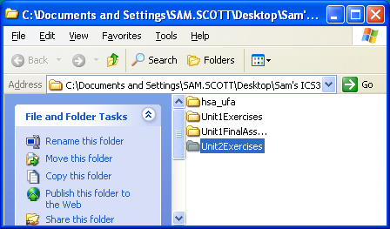

- When handing in your programs, you should right click the folder, and choose “Send to Compressed Folder”. This will create a single file that contains the entire folder. Then attach this file to your VUFA message when handing in.

- A common mistake: If your programs won’t run, it could be because you have another hsa_ufa folder inside the top hsa_ufa folder. Make sure when you open hsa_ufa you see a bunch of .java and .class files, and not just another folder.

